Mini Project: Customer Sales Insights

Q1. Who are the top 5 customers?
I used SUM(Sales) with GROUP BY to calculate total sales for each customer. Then I sorted the results in descending order and selected the first five records using LIMIT 5.
SELECT
c.`Customer Name`,
SUM(o.Sales) AS Total_Sales
FROM orders o
JOIN customers c
ON o.`Customer ID` = c.`Customer ID`
GROUP BY c.`Customer Name`
ORDER BY Total_Sales DESC
LIMIT 5;
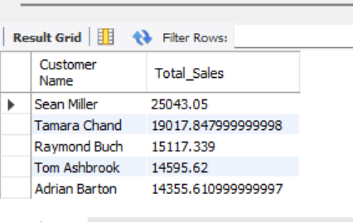

Q2. Who are the bottom 5 customers?
This query groups sales by customer and calculates their total sales. The results are sorted in ascending order to identify the customers with the lowest sales contribution.
SELECT
c.`Customer Name`,
SUM(o.Sales) AS Total_Sales
FROM orders o
JOIN customers c
ON o.`Customer ID` = c.`Customer ID`
GROUP BY c.`Customer Name`
ORDER BY Total_Sales ASC
LIMIT 5;
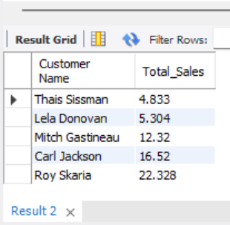

Q3 . Which customers made only one order?
I counted distinct order IDs for each customer and used the HAVING clause to filter customers whose order count is exactly one.
SELECT
c.`Customer Name`,
COUNT(DISTINCT o.`Order ID`) AS Order_Count
FROM orders o
JOIN customers c
ON o.`Customer ID` = c.`Customer ID`
GROUP BY c.`Customer Name`
HAVING COUNT(DISTINCT o.`Order ID`) = 1;
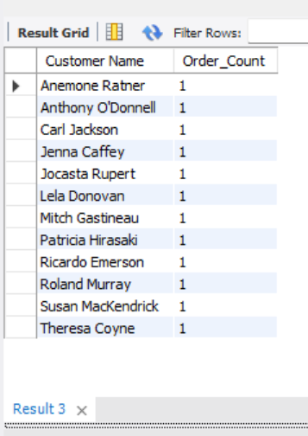

Q4. Which customers have above-average sales?
First, I calculated total sales for each customer using a CTE. Then I compared each customer's total sales with the average of all customer sales using a subquery.
WITH customer_sales AS
(
SELECT c.`Customer Name`, SUM(o.Sales) AS Total_Sales
FROM orders o
JOIN customers c
ON o.`Customer ID` = c.`Customer ID`
GROUP BY c.`Customer Name`
)
SELECT *
FROM customer_sales
WHERE Total_Sales >
(
SELECT AVG(Total_Sales)
FROM customer_sales
);
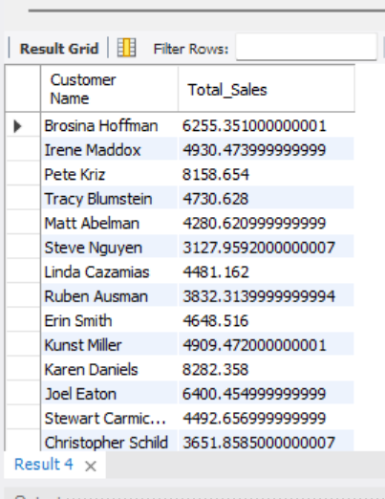

Q5. What is the highest order value per customer?
I used the MAX() function to find the highest sales amount recorded for each customer and grouped the results by customer name.
SELECT
c.`Customer Name`,
MAX(o.Sales) AS Highest_Order_Value
FROM orders o
JOIN customers c
ON o.`Customer ID` = c.`Customer ID`
GROUP BY c.`Customer Name`
ORDER BY Highest_Order_Value DESC;

